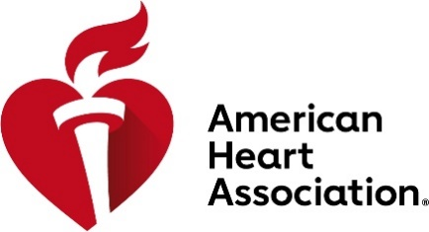

Mingo survivor named national Youth Heart Ambassador
American Heart Association youth volunteers to share their story to inspire others.
Mingo, WV – 9/1/2022 — The American Heart Association, devoted to a world of healthier lives for all, has selected the 2022-2023 class of Youth Heart Ambassadors to be the face and voice in the American Heart Associations’ in-school initiatives sharing their story to actively and passionately champion other children to establish healthy habits to better mental and physical well-being. Hillary Gore, a junior at Mingo Central High School, has been selected for the volunteer role.

The Youth Heart Ambassadors serve a one-year commitment as a volunteer of the American Heart Association assisting the organization to be a relentless force for healthier lives for all. The position gives youth a voice to encourage, advocate and underscore the need for to raise critical funding as they share the impact cardiovascular disease has had on their life. The American Heart Association accepted nominations from youth who have been affected by heart disease or stroke either through a personal diagnosis, diagnosis of a loved one, or has made a personal lifestyle change, to serve in the Youth Heart Ambassador role.

“Being the National ambassador for the American Heart Association honestly made my year,” said Gore. “Since I was in kindergarten, I’ve been helping them fundraise to help save lives like mine. I’m so grateful to have this opportunity to spread the importance of heart health not only in my state, but nationally as well.”

The Youth Heart Ambassadors works closely with the American Heart Association’s in-school programs, Kids Heart Challenge and American Heart Challenge. With deep roots in physical activity, Kids Heart Challenge and American Heart Challenge have expanded beyond the gym to meet the needs of today’s youth and educators as science has proven the strong connection between physical and mental health. Both programs’ curriculums help prepare youth for success by supporting their physical and emotional well-being.

“I am very excited to take the journey with Hillary in promoting Heart Health Education and awareness through our Kids Heart and American Heart Challenges this year,” said Wendy Bradley, Youth Markets Director for the American Heart Association. “She will be an incredible role model for so many on how to live a heart healthy life! Helping her integrate her ideas to bring even more awareness to her community and to the schools is going to be inspiring! We both are ready to help everyone make the change to living healthier lives!”

Schools interested in participating in either Kids Heart Challenge or American Heart Challenge to receive expanded curriculum resources for both classrooms and in-home learning environments can register now for next school year. To learn more about our school programs please visit www.heart.org/schools. More information can be found online, heart.org/youthambassadors.

###

About the American Heart Association
The American Heart Association is a relentless force for a world of longer, healthier lives. We are dedicated to ensuring equitable health in all communities. Through collaboration with numerous organizations, and powered by millions of volunteers, we fund innovative research, advocate for the public’s health, and share lifesaving resources. The Dallas-based organization has been a leading source of health information for nearly a century. Connect with us on heart.org, Facebook, Twitter or by calling 1-800-AHA-USA1.

For Media Inquiries:
Kevin Pauley: 304-444-6494; kevin.pauley@heart.org
Public Inquiries: 1-800-AHA-USA1 (242-8721)
heart.org and stroke.org

